***DO NOT WRITE ON THIS FORM***

Grade 7
Common Core
English Language Arts
KPREP SCRIMMAGE PACKET
(engage^{ny} KPREP State Testing Released Items, May 2016 - modified)

Answer Key
(Multiple Choice)

Excerpts from Into the Unknown
1 - B
2 - A
3 - A
4 - D
5 - C
6 - C
7 - C

Rethinking Youth Sports to Prevent Kids’ Head Injuries
8 - D
9 - C
10 - C
11 - A
12 - B
13 - C
14 - A
Excerpts from The Car
15 - C
16 - D
17 - B
18 - A
19 - B
20 - C
21 - B

How to Fix School Lunch
22 - C
23 - A
24 - B
25 - A
26 - C
27 - C
28 - A

29 and 30
2016 Scoring Materials ELA G7
Pg 97-130 for Possible Exemplary Responses and Scoring Guides

Excerpt from Buddha Boy and Excerpt from One + One = Blue

(Short Response – 1 paragraph = 2 pts) pg 97
In “Excerpt from One + One = Blue,” what effect does the differene in Basil’s point of view and Tenzie’s point of view regarding Basil’s family have on the story Use two details from the story to support your respose.

(Extended Response – Essay = 4 pts) pg 107
In “Excerpt from Buddha Boy” and “Excerpt from One + One = Blue,” both Justin and Basil take chances they learn from. What chances do they each take? What do they learn about themselves through the conversations and events in each story? Use details from both stories to support your response.
In your response, be sure to:
- Explain what chances Justin and Basil each take.
- Explain what they learn about themselves through the conversations and events in each story.
- Use details from both stories to support your response.

***DO NOT BUBBLE #29 and #30***
Name:____________________
Date:_____________________
Test Administrator:__________
***RUBRIC GRADE – TEACHER USE ONLY***

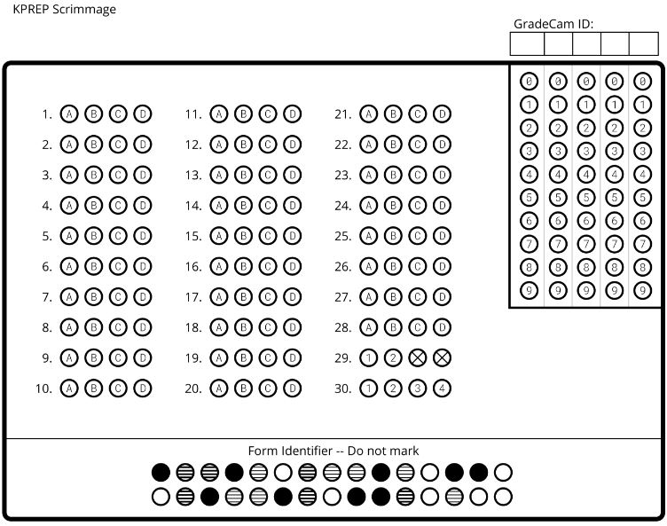
Answer questions 29 and 30 on a separate piece of notebook paper. 29 is a short one paragraph response (3-5 sent). 30 is an extended 5 paragraph (3-5 sent each) response. Be sure to put your name on all pages used and number your responses.
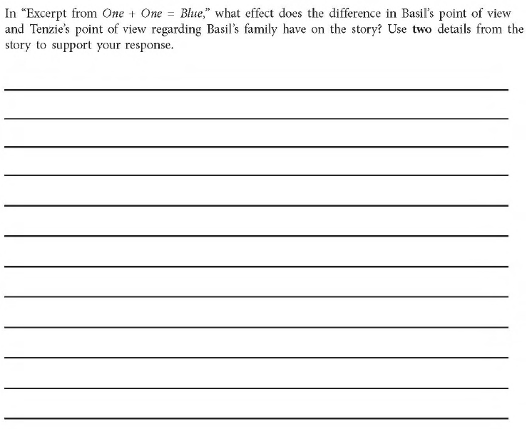
29.)

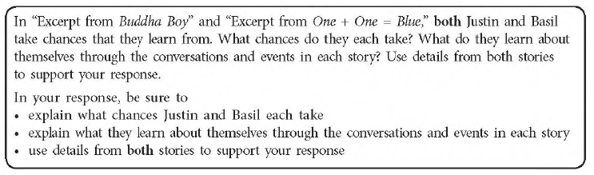
30.)

Answer Key (Multiple Choice)

Excerpts from Into the Unknown
1 - B
2 - A
3 - A
4 - D
5 - C
6 - C
7 - C

Rethinking Youth Sports to Prevent Kids’ Head Injuries
8 - D
9 - C
10 - C
11 - A
12 - B
13 - C
14 - A
Excerpts from The Car
15 - C
16 - D
17 - B
18 - A
19 - B
20 - C
21 - B

How to Fix School Lunch
22 - C
23 - A
24 - B
25 - A
26 - C
27 - C
28 - A

